**Mobile Pain Management Clinic**

Colorado ranks 2nd in the nation for opioid abuse (Jesse Paul, 2016). Colorado has experienced an increase of overdose death rates in every county, except one in Colorado with Denver initially being the most prevalent. CDPHE reports that the use of prescription opioid drugs has the potential to lead to patient abuse of these medications, addiction, and diversion, with death rates of nearly 6 per 100,000 people compared to the death rates of heroin (2 per 100,000 people). Opioid prescription abuse has increased costs of excessive health care utilization. So our aim is to implement a multidisciplinary approach to managing prescription opioid abuse through reduction of prescription and improved management of individuals with a history of opioid abuse. A study by Deyo et al 2009 showed that >50% of the prescriptions of opioids are patients with chronic lower back pain. Our approach is to establish a team of mobile pain management specialists partnered with Denver-Health targeting 1000 patients with chronic lower back pain.

Proposal for program implementation in a 3-year timeframe:

* **Year 1**: We build a mobile pain management specialist’s team consisting of medical professionals such as pain specialists, physical therapists, nurses, and psychologists. If necessary specialized population healthcare professionals such as OBGYN and occupational health therapists will be consulted as needed.
  + The consultation appointment agenda includes:
    - collecting patient medical history, health literacy and mental health assessment
    - providing alternative therapies for pain management.
    - exam and pain assessments will help diagnose severity of pain and allow professionals to create alternative treatment plans based on individual patient need
    - Teach back
  + Plan: the patient goes to the ER, ER doctor consults with our specialized Pain Management Team. The pain management team will treat the patient, patient gets discharged. Pain management team will travel to the patient for follow-up to supplement standard care à reduce near term hospital readmissions
* **Year 2**: Partner with project ECHO to train primary care providers to educate patients on pain management using our appointment agenda.
* **Year 3**: Pain management for more serious cases, if PCP cannot adequately manage case or patient needs more attention, than our pain management specialists will be called in.

Budget: 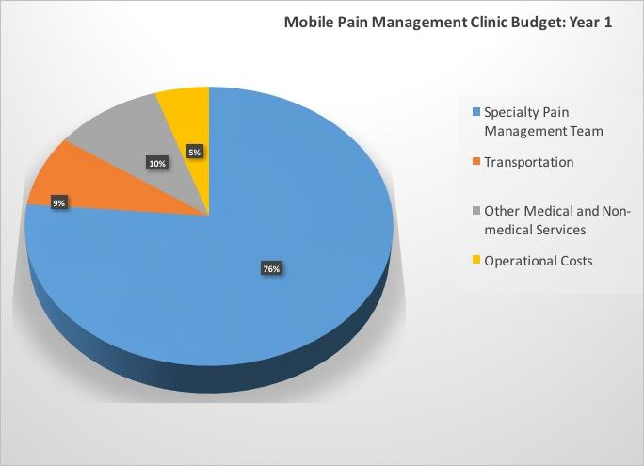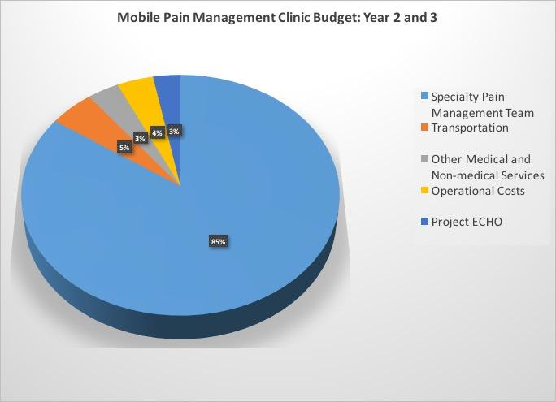

·

**References**

Acupuncture Association of Colorado. Retrieved November 12, 2016, from <http://acucol.com/http/acucol.com/acupuncturists-area>

Centers for Medicare and Medicaid Services. Federally Qualified Health Centers. Retrieved November 12, 2016, from https://www.cms.gov/Center/Provider-Type/Federally-Qualified-Health-Centers-FQHC-Center.html

Daley, J. (2016, February 16). Colorado drug overdoses up in almost every county and ahead of national average. Retrieved November 12, 2016, from http://www.cpr.org/news/story/colorado-drug-overdoses-almost-every-county-and-ahead-national-average

Denver Health. (2016). Retrieved November 12, 2016, from <http://www.denverhealth.org>

Goldberg, J. (2016, July 30). Hypnosis and Mental Health. WebMD Retrieved July 30, 2016 from <http://www.webmd.com/anxiety-panic/guide/mental-health-hypnotherapy?page=2>

Hahn, K. L. (2011). Strategies to prevent Opioid misuse, abuse, and diversion that may also reduce the associated costs. *American Health and Drug Benefits*, *4*(2), 107–114. Retrieved from https://www.ncbi.nlm.nih.gov/pmc/articles/PMC4106581/

Longo, D. L., Volkow, N. D., & McLellan, A. T. (2016). Opioid abuse in chronic pain — misconceptions and mitigation strategies. *New England Journal of Medicine*, *374*(13), 1253–1263. doi:10.1056/nejmra1507771

Mobile health Apps interactive tool. (2016, April 4). Retrieved November 12, 2016, from <https://www.ftc.gov/tips-advice/business-center/guidance/mobile-health-apps-interactive-tool>

Pain Management Center (2016). Pain management center. Retrieved November 12, 2016, from <https://stanfordhealthcare.org/medical-clinics/pain-management.html>

Pfizer. (2002). Newest Vital Sign Toolkit. Retrieved November 12, 2016, from Pfizer, <http://www.pfizer.com/health/literacy/public_policy_researchers/nvs_toolkit>

Project ECHO Colorado. (2015, September 26). Retrieved November 12, 2016, from https://echocolorado.org/partners-2/

Rowbotham, M. C. (2012). *What alternatives are there to the use of opioid analgesics in the treatment of chronic pain in light of existing evidence and its limitations?* Retrieved from http://www.fda.gov/downloads/drugs/newsevents/ucm307837.pdf

Stanaway, N. (2016, May 23). Community Paramedic Program Cuts Mental Health Patient Call Volume. Retrieved November 12, 2016, from EMS, <https://www.ems1.com/community-paramedicine/articles/93357048-Community-paramedic-program-cuts-mental-health-patient-call-volume/>

Stanos S. Focused review of interdisciplinary pain rehabilitation programs for chronic pain management. *Curr Pain Headache Rep*. 2012;16:147-152.

Strategies to Reduce Prescription Drug Abuse Lessons Learned from the ACAP SUD Collaborative. (2015). . Retrieved from http://www.communityplans.net/portals/0/fact%20sheets/ACAP_Substance_Use_Disorder_Toolkit.pdf

Sullivan, M. D., Edlund, M. J., Zhang, L., Unützer, J., & Wells, K. B. (2006). Association between mental health disorders, problem drug use, and regular prescription Opioid use. *Archives of Internal Medicine*, *166*(19), 2087. doi:10.1001/archinte.166.19.2087

The Health Law Firm (2011, December ). Recent Changes to Florida’s Pain Management Laws 2011-2012. Retrieved November 12, 2016, from The Health Law Firm, <http://www.thehealthlawfirm.com/resources/health-law-articles-and-documents/florida-pain-management-laws.html>

Turk DC, Stanos SP, Palermo ™, et al. (2010). Interdisciplinary Pain Management, Glenview, IL: American Pain Society

Turk DC, Wilson HD, Cahana A. (2011) Treatment of chronic non-cancer pain. Lancet.